|  |  |  |  |
| --- | --- | --- | --- |
| NXP Semiconductors | Document Number: | | |
| Quick Start Guide | Rev. 0.1 | , | 06/2018 |

MCUXpresso SDK USB Host RNDIS & LWIP

User's Guide

Contents

Alejandra Guzman – Optional

1. Introduction 1

2. Software 2

2.1. Folder structure 2

2.2. Features 3

2.3. Building the Demo 3

3. Hardware 3

4. Run Demo 3

4.1. Setup boards 3

4.2. Begin to run 4

4.3. Insert USB device 4

4.4. Details steps to turn on USB tethering feature on the Cellphone 5

5. Known issue 7

# Introduction

USB tethering feature on the cell phone could be used to get the full access to the internet. This document describes how to use the USB Host RNDIS & LWIP example provided in the MCUXpresso SDK to access the internet via a cellphone which turns on the USB tethering function.

# Software

The document will take MCUXpresso SDK2.4 evkbimxrt1050 package as example. The folder on other boards are similar to this.

## Folder structure

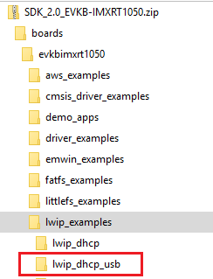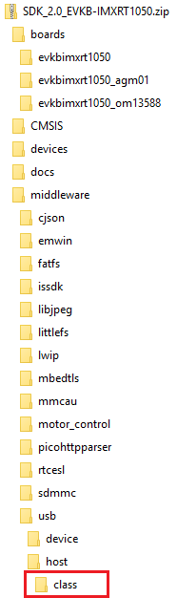

|  |  |
| --- | --- |
| **Folder** | **Description** |
| boards/  CMSIS/  devices/  docs/  middleware/  rtos/ | MCUXpresso SDK2.x evkbimxrt1050 package directory. |
| boards/evkbimxrt1050/lwip_examples/lwip_dhcp_usb | The USB RNDIS & lwip example directory. |
| middleware/usb/host/class | USB RNDIS class driver |
| Middleware/lwip/port | USB ethernet interface driver |

## Features

* One example (lwip_dhcp_usb) is provided. The lwip_dhcp_usb example is a simple demonstration which integrates the USB Host RNDIS and lwIP TCP/IP stack, the example would
  + Connect to a cellphone which turns on the USB tethering feature
  + Get ip address via DHCP
  + Ping [www.nxp.com](http://www.nxp.com)
* Both BM and FreeRTOS are supported

## Building the Demo

The demo projects are located in the below path.

*<root>/boards/board_name/lwip_examples/lwip_dhcp_usb/<rtos>/<toolchain>.*

*Note: The <rtos> would be “bm” for Bare Metal or “freertos” for FreeRTOS OS.*

Please refer root/docs/Getting Started with MCUXpresso SDK for xxxx(board name).pdf to know how to build the demo/download the binary to the board

# Hardware

• Micro AB to standard A USB converter

• USB A to micro AB cable

• Personal Computer(PC)

• mobile phone with Android OS

MEIZU Note 3 – OS is Flyme 6.1.0.1M

Moto G – Android 8.1.0

Honor 10 of HUAWEIE– MUI 8.1.0

# Run Demo

## Setup boards

1. Set the hardware jumpers to default settings.
2. Make sure USB port has power. Refer to the readme.txt.
3. Refer to Section 2.3 and make sure the lwip_dhcp_usb demo has been built and downloaded to the board.
4. Connect UART to PC. Configure the com port in pc to get debug information.
5. Open the com port in PC device manager with serial tool, such as tera term.

## Begin to run

1. Power on the board, the following information is print in the terminal.

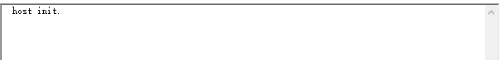

## Insert USB device

1. Connect the mobile phone to usb port on the your board.
2. The example will print the following log in the terminal.



1. For the steps to turn on usb tethering feature, please reference to the 4.4.
2. After the feature is enabled. The lwip example will enumerate the mobile phone as cdc device and print the follow log in the terminal.

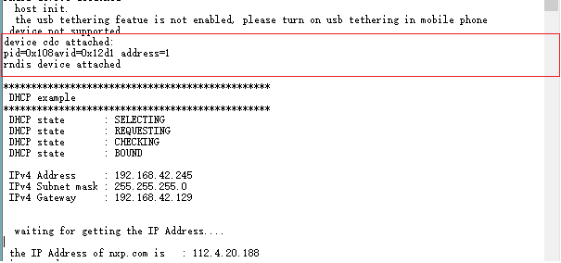

1. After mobile phone is enumerated, the example will get IP address and keep ping, the following log is print in the terminal

Note:

The IP information and IP address of nxp website may be different in different scenario.

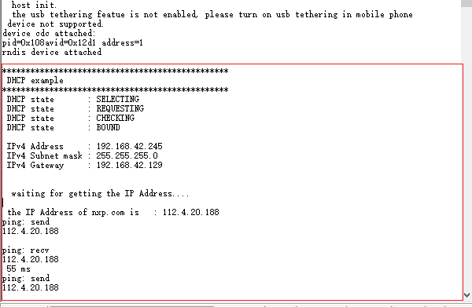

## Details steps to turn on USB tethering feature on the Cellphone

Note: The following steps are used on Honor 10 cellphone on Android 8.1.0, for other cellphone or other Android version, the steps might be different.

Find the system setting in mobile phone. Check the Wireless & networks.

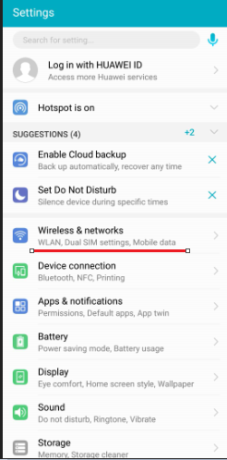

1. Check the Tethering & portable hotspot.

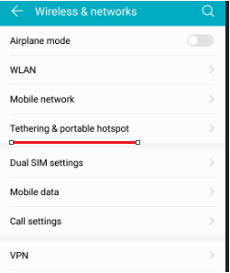

1. Before the mobile phone is connected to an USB RNDIS Host, the USB tethering feature can’t be enabled.

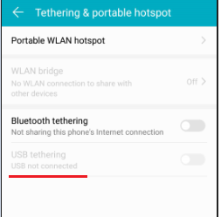

1. After the mobile phone is connected to an USB RNDIS Host, the USB tethering feature could be enabled now

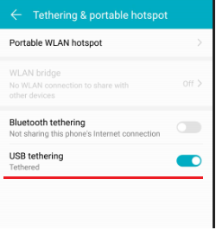

# Known issue

1. if mobile phone is plugged out and then plugged in again when lwip example is ping, the ping command can’t get feedback. This could only be found on MEIZU Note 3.

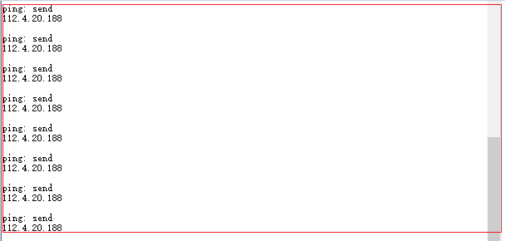



***How to Reach Us:***

**Home Page:**

[nxp.com](http://www.freescale.com/)

**Web Support:**

[nxp.com/support](http://www.freescale.com/support)

Information in this document is provided solely to enable system and software implementers to use NXP products. There are no express or implied copyright licenses granted hereunder to design or fabricate any integrated circuits based on the information in this document. NXP reserves the right to make changes without further notice to any products herein.

NXP makes no warranty, representation, or guarantee regarding the suitability of its products for any particular purpose, nor does NXP assume any liability arising out of the application or use of any product or circuit, and specifically disclaims any and all liability, including without limitation consequential or incidental damages. “Typical” parameters that may be provided in NXP data sheets and/or specifications can and do vary in different applications, and actual performance may vary over time. All operating parameters, including “typicals,” must be validated for each customer application by customer’s technical experts. NXP does not convey any license under its patent rights nor the rights of others. NXP sells products pursuant to standard terms and conditions of sale, which can be found at the following address: nxp[.com/SalesTermsandConditions](http://www.freescale.com/SalesTermsandConditions).

Registered trademarks: NXP, the NXP logo, NXP SECURE CONNECTIONS FOR A SMARTER WORLD, COOLFLUX, EMBRACE, GREENCHIP, HITAG, I2C BUS, ICODE,

JCOP, LIFE VIBES, MIFARE, MIFARE CLASSIC, MIFARE DESFire, MIFARE PLUS, MIFARE FLEX, MANTIS, MIFARE ULTRALIGHT, MIFARE4MOBILE, MIGLO, NTAG, ROADLINK, SMARTLX, SMARTMX, STARPLUG, TOPFET, TRENCHMOS, UCODE, Freescale, the Freescale logo, AltiVec, C-5, CodeTEST, CodeWarrior, ColdFire, ColdFire+, C-Ware, the Energy Efficient Solutions logo, Kinetis, Layerscape, MagniV, mobileGT, PEG, PowerQUICC, Processor Expert, QorIQ, QorIQ Qonverge, Ready Play, SafeAssure, the SafeAssure logo, StarCore, Symphony, VortiQa, Vybrid, Airfast, BeeKit, BeeStack, CoreNet, Flexis, MXC, Platform in a Package, QUICC Engine, SMARTMOS, Tower, TurboLink, and UMEMS are trademarks of NXP B.V. All other product or service names are the property of their respective owners.

ARM, the ARM logo, and Cortex are registered trademarks of ARM Limited (or its subsidiaries) in the EU and/or elsewhere. mbed is a trademark of ARM Limited (or its subsidiaries) in the EU and/or elsewhere. All rights reserved.

IEEE nnn, nnn, and nnn are registered trademarks of the Institute of Electrical and Electronics Engineers, Inc. (IEEE). This product is not endorsed or approved by the IEEE. Java are registered trademarks of Oracle and/or its affiliates. The Power Architecture and Power.org word marks and the Power and Power.org logos and related marks are trademarks and service marks licensed by Power.org. (Add contract language here, as necessary.)

© 2016 NXP B.V.

This boiler plate is not ready for publication until the steps found in the Freescale Trademark Attribution Worksheet have been completed. You can access it here: [http://compass.freescale.net/go/ 215485375](http://compass.freescale.net/go/%20215485375) .

Note also that the ARM attribution must be updated from “ARMnnn” to reflect the correct product name.

COMPANY PROPRIETARY

PRELIMINARY